6-1 Journal: Explore Object-Oriented Programming
Describe your chosen practical application and why you chose it: Employee control access matrix
A practical application of object-oriented programming would be the creation of an employee control access matrix in which the parent class is a general employee information category storing the name, employee ID, and job title while the child classes are unique to the employee’s job role and grant or restrict access to portions of the system based on their job title. For this scenario the job titles will be Staff Accountant, Assistant Controller, Controller, and Chief Financial Officer; and the control access matrix will ensure proper internal control based on the employee’s role within the company. For example, an employee should not be responsible for reviewing their work, and accessing certain segments of the system that are not part of the employee’s role should not be allowed to reduce the risk of errors or fraud in the financial information produced by a company. In this scenario, the Staff Accountant is responsible for data entry into the system and creating reconciliations. The Assistant Controller is responsible for reviewing the work done by the Staff Accountant and the compilation of the company’s financial statements. The Controller is responsible for reviewing the compiled financial statements. Finally, the Chief Financial Officer does the final review of the financial statements but makes no changes within the system. Each successive level in the pyramid should have read-only access to the information prepared by the previous employee, see Figure 1 for the code and Figure 2 for the output access control matrix.
Explain key OOP concepts in your chosen application:
Classes and objects: the classes in this example are the initial Employee definition as well as the classes for each job title type: Staff Accountant, Assistant Controller, Controller, and Chief Financial Officer. The classes create a template for the objects to follow to remove the redundancy in the code. In this example of the objects are the four employees: Alison Alley, Beatrice Benny, Carl Carlson, and Debbie Downtown.
Inheritance: this practical application demonstrates inheritance since each employee job title type inherits information from the parent class called Employee, as seen in Figure 1 lines 13, 21, 29, and 36. This removes the redundancy of having to reenter the information for each employee in the job title section of the code, rather it pulls it automatically from the parent to the child class.
Encapsulation: this example uses encapsulation since each job title has pre-defined class access control to the financial reporting system of the company. Rather than assigning access on an individual employee basis, the access is granted on the job title level, reducing the chances of unauthorized access given by accident or with the intention of committing fraud. This allows access for all employees with a given job title to be updated in one central place instead of in each instance of the employee in the code creating updating efficiency and modularization in the code.
Polymorphism: this scenario involves polymorphism since each employee has the same base type of Employee storing their name and employee ID, but each object is treated differently based on the employee’s assigned job title in the access control matrix which is based on their assigned role within the company.
Explain the benefits of OOP concepts for your chosen application:
Effect on the end user: the main benefits to the end user of this control access matrix made using object-oriented programming is the speed with which it can be updated as new employees join the company or as existing employees get promoted within the company. For example, if they added a new job title for an Intern, the developer could easily copy from the Staff Accountant class and make changes as needed or if an employee was promoted this change in status could easily be updated by the developer. This speed and efficiency would reduce the lag experienced by the employees using the system while they wait for the updates to be completed, leading to more efficient change management operations within the company and increased productivity.
Effect on the developer: As Figure 1 demonstrates the developer only needs to assign relevant access to the financial reporting system based on the employee’s job title once instead of having to assign this access for each employee that is hired reducing the chances for incorrect access and a significant amount of redundancy in the code. It allows the broad project of giving system access to employees to be broken down into smaller more manageable components that can be used to base additional job titles sub-classes as new positions arise within the company.
Effect on the program structure and performance: As a result of implementing object-oriented programming, the code used to create the access control matrix is more efficient and concise than if each sub-class, or job title, needed to include the information that was previously stored in the main Employee class. If changes are made to one job title’s access controls, like Assistant Controller, and a bug is inadvertently created it will only impact the individuals with that job title access and will have no impact on the other employees.

Figure 1: Python Code Example
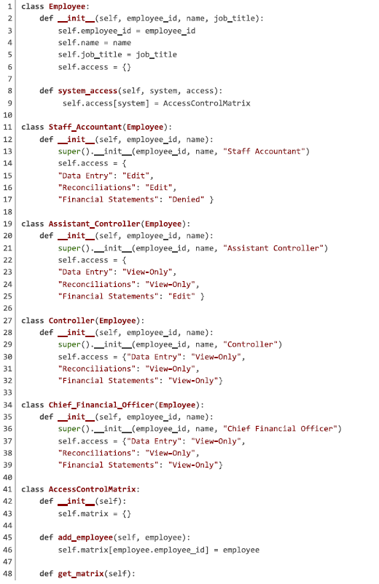
Figure 1: Python Code Example (Concluded)
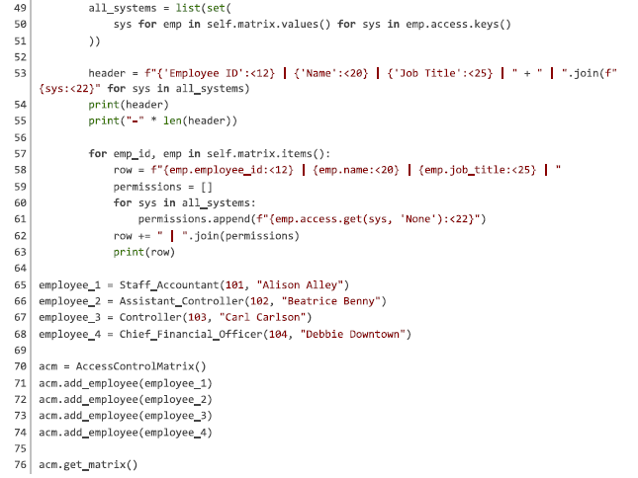

Figure 2: Python Code Terminal Output

